Learning Exercises

* 18.6
  + Consider the following date set comprised of 3 binary input attributes(A1, A2, and A3) and one binary output

|  |  |  |  |  |
| --- | --- | --- | --- | --- |
| **Example** | A1 | A2 | A3 | Output *y* |
| X1 | 1 | 0 | 0 | 0 |
| X2 | 1 | 0 | 1 | 0 |
| X3 | 0 | 1 | 0 | 0 |
| X4 | 1 | 1 | 1 | 1 |
| X5 | 1 | 1 | 0 | 1 |

Use the algorithm in figure 18.5(pg 702 to learn a decision tree for these data. Show the computations made to determine the attribute to split at each node

* + - A1 Tree has a pure leaf with one output
      * 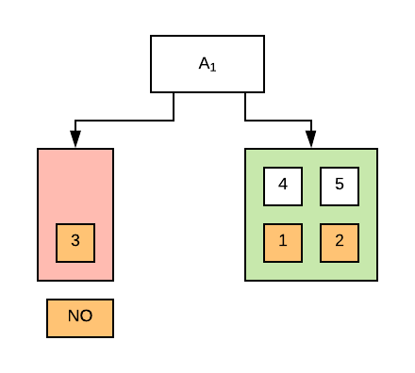
    - A2 Tree has one pure leaf with 2 Outputs
      * 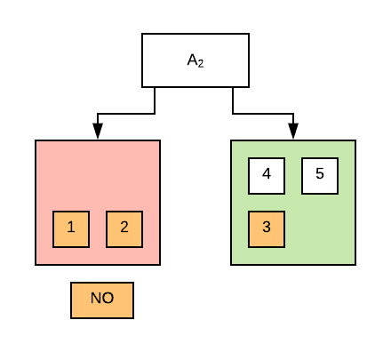
    - A3 is Impure
      * 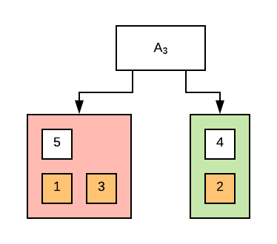
    - Because A2 Has the most outputs in one pure leaf, that becomes the Root
      * The only negative output left after A2 is output 3 which is the only possible negative output in A1 so that becomes the second test
      * After the second test, the tree’s leaves are entirely pure
      * 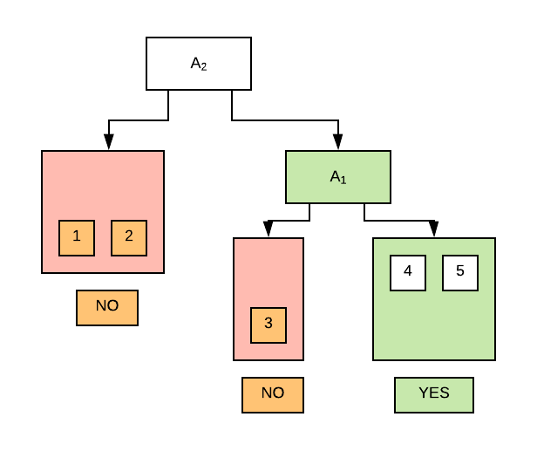
* 19.1
  + Show by Translating into conjunctive normal form and applying resolution, that the conclusion drawn on page 784 concerning Brazilians is sound
    - “If x and y have the same nationality n and s speaks language l, then y also speaks it”
    - Conjunctive Normal Form
      * N(x, n) ˄ N(y, n) ˄ L(x, l) -> L(y, l)
      * Conclusion
        + N(x, n) => L(x, l)
    - Resolution
      * N(x, n) ˄ N(y, n) ˄ L(x, l) => L(y, l)
      * ¬(N(x, n) ˄ N(y, n) ˄ L(x, l)) v L(y,l)
      * (¬N(x, n) v ¬N(y, n) v ¬L(x, l)) v L(y, l)
      * N(x, n) => L(x, l)